
Negative powers

A catenary is the name given to describe the curve that appears when a chain is suspended from two points. Suspension bridges are everyday examples of cables exhibiting this shape.
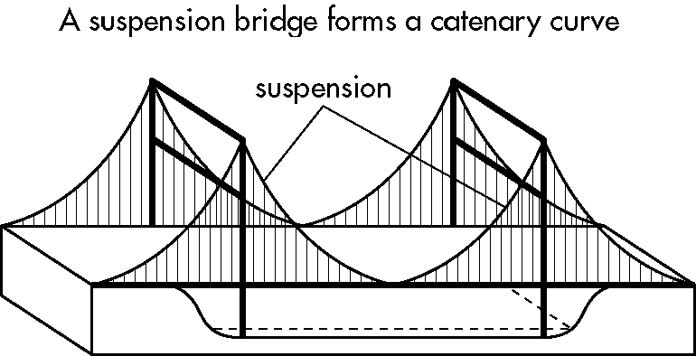
Builders in pre-Renaissance times constructed bridges using the catenary shape. Each stone block used was balanced exactly by the supporting forces of the rest of the arch.
Due to this special property of the curve, the blocks did not need...
Find out the answer by solving the following, showing all your working in the space provided. Write the question’s code letter above its solution in the tables on the next page.
Simplify the following, expressing your answers with positive indices.
B 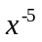 | R 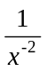
D 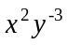 | O 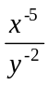
K 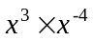 | H 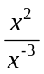



E 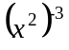 | T 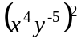
U 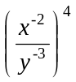 | C 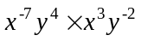
I 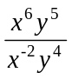 | S 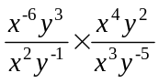
G 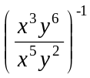

Due to this special property of the curve, the blocks did not need...
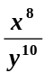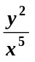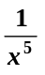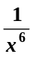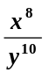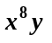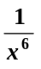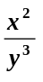

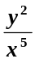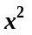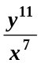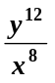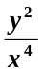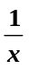

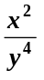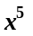

Negative powers
Answers

B: 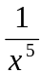, R: x², D: 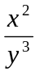, O: 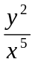, K: , H: x⁵, E: 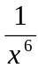, T: 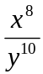, U: 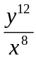, C: 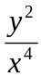, I: x⁸y,
S: 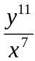, G: 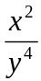

TO BE TIED OR STUCK TOGETHER

